Linear algebra

Spaced:
Questions1:
What is centered difference matrix?
2: what is linear combination?
3: what is span of a vector set?
4: how do you get to any vector, anywhere in R^n, using basis vectors?
5: what span R^n?
hw1
problem4
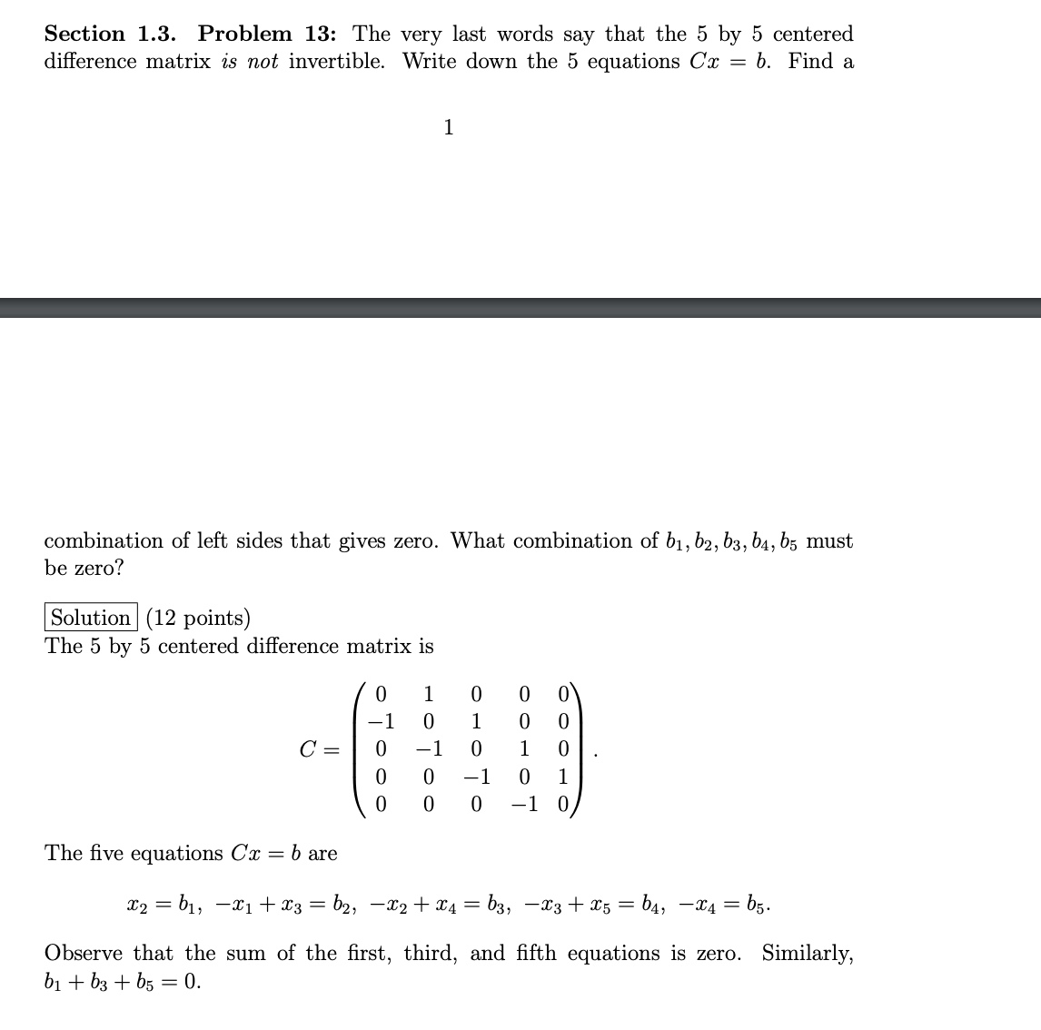
1
Linear combination: the sum of scaled vectors
2
The span of a set of vectors: the collection of all vectors which can be represented by some linear combination of the set
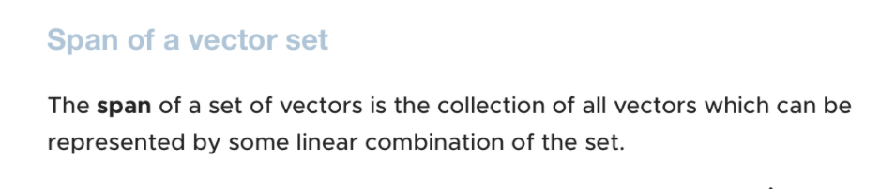
3
What does
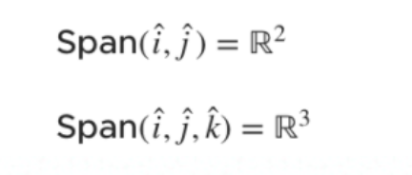
mean?
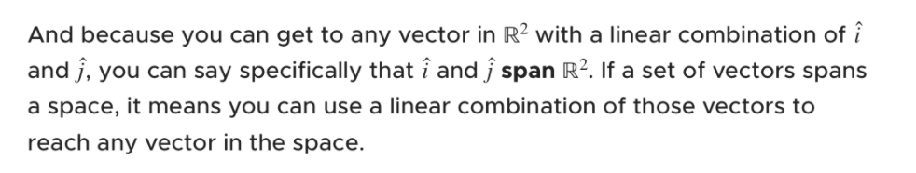
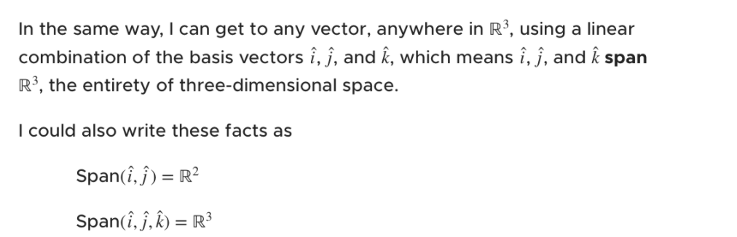

4what spans what? What can span R^n?
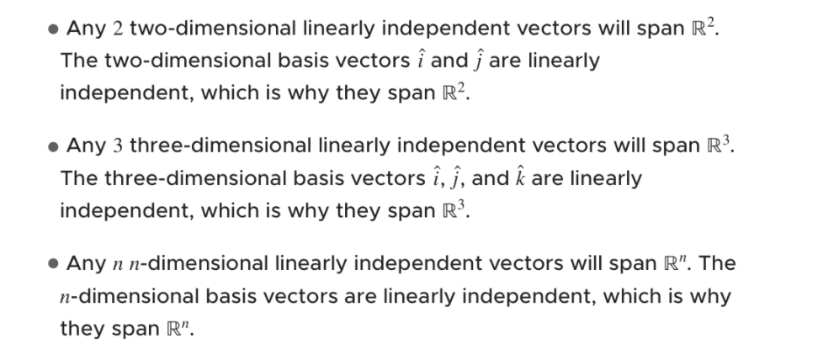
5prove that we can use a linear combination of the basis vectors i and j to get any vector k in R^2
